Background of Quantum Computing

The general steps of computing are as follows. First, we make a lot of initial states. Then we do operations on them. Ultimately they evolve into their final states and we measure them to get the information we want. In classical computing, a physical state is represented by voltage and operations are the gates in digital circuits. One bit can have two states, high voltage or low voltage.

In quantum computing, however, the physical state is a quantum state which can have a superposition. Superposition means that a quantum state can stay in both state 1 and state 0 at the same time. We call it a qubit. Similar to the classical gates in digital circuits, operations on qubits are quantum gates. There are different kinds physical implementation of quantum circuits, one of the most common approaches is microwave. We can exert microwave on the qubits to operate their states.

Mathematically a qubit can be represented by a vector (\alpha \beta) which means \alpha 0 + \beta 1. \alpha and \beta are the coefficients of superposition. A quantum gate is represented by a matrix ( ). So doing an operation on a qubit through a quantum gate is to multiply the quantum gate matrix with the qubit vector and it turns out to be a new vector which represents the result qubit.

There are mainly two kinds of quantum gates, single-qubit gates and two-qubit gates. The former one operates just one qubit and the latter one operates two qubits. Here are the common single-qubit gates and their matrix form. Among them, Hadamard gate has a special property that HH=I, I is the identity matrix. So two sequential Hadamard gates can offset each other because their total effect is equivalent with doing nothing to the qubit. This is very useful in bridge transformation discussed below. The most commonly used two-qubit gate is CNOT gate. CNOT(x,y) denotes a CNOT gate between qubit x and y. Qubit x is called the controlling qubit and qubit y is the controlled qubit. CNOT(x,y) and CNOT(y,x) are different quantum gates because they have different effects on the qubit states.

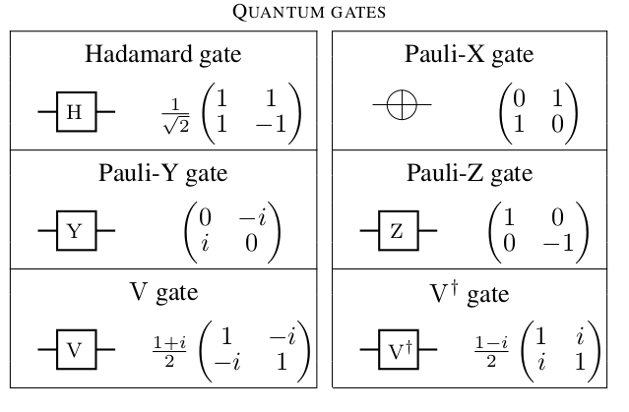

Theory: All the single-qubit gates and CNOT gate can realize all quantum logic. So the only two-qubit gate appearing in the quantum circuits is CNOT gate.

The software toolflow of quantum computing is as follows. First we write our algorithm in a high-level language, and then put it into the compiler. The compiler conducts some optimizations on our original codes and generate the concrete quantum circuits which is described in a certain kind of assembly language such as QASM. The qubit used in a quantum circuit is pseudo qubit because they haven’t been mapped into the real hardware. So the last step of software toolflow is to map the pseudo qubits into the physical qubits in the hardware which is called qubit allocation.

Qubit Allocation

Here is the quantum computing hardware offered by IBM which is called ibmqx2. Each node in the hardware graph represents a physical qubit and each edge means there’s a unidirectional connection between the two physical qubits. So the hardware graph is a hardware network with unidirectional edges. Physically different qubits have various frequencies and only the qubit with higher frequency can control the qubit with lower frequency, otherwise it will be a weak link. So CNOT operations can only be implemented between the connected qubits with specific direction. For example, there’s an edge from physical qubit Q0 to Q1, it means CNOT(Q0,Q1) can be implemented in the hardware but CNOT(Q1,Q0) is prohibited. This characteristic of the architecture can bring problems for qubit allocation.
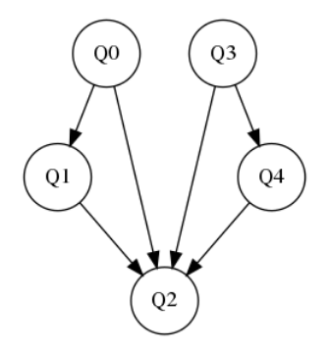
Example 1:
This is a quantum circuit. It consists of several single-qubit gates and CNOT gates. We extract the operands of CNOT gates and form a sequence which is called dependency sequence. The item (qx,qy) in dependency sequence means there’s a CNOT(qx, qy) gate in the circuit where qx, qy represent pseudo qubits. Here is the dependency sequence of the quantum circuit. Our goal is to map all the pseudo qubits in the quantum circuit to the physical qubits in the hardware and implement all the CNOT gates in dependency sequence. To show this task more clearly, we can draw a directed graph which is called coupling graph based on the dependency sequence. The unidirectional edge between q0 and q1 in the coupling graph denotes there’s a CNOT operation from q0 to q1. All the pseudo qubits and CNOT gates in the quantum circuit comprise the coupling graph. Therefore, our job is to find a subgraph in the hardware graph which can match all the directed edges in the coupling graph. However, it’s impossible to find such a mapping under most of the cases. For example, the quantum circuits we show cannot be satisfied by the ibmqx2. Just look at the pseudo qubit q1 in the coupling graph, its in-degree is 2 and out-degree is 1 and no such vertex can be find in the hardware graph. So it’s impossible to find a mapping between pseudo qubits and physical qubits to implement all the CNOT gates in the dependency sequence.
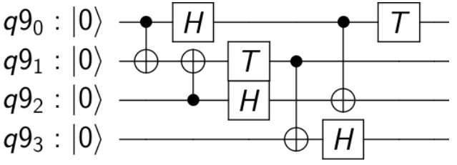
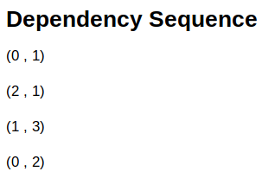
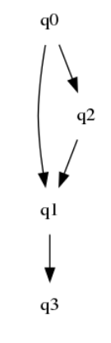

To solve this problem, we need to some transformations on the original quantum circuits, that is, add some additional gates to the original circuit and enable it to satisfy the dependency sequence.

There are 3 kinds of transformations.
Reversal transformation is used to change the direction of an edge temporarily. To be more specific, we want to implement CNOT(qx, qy) but there only exists a directed edge from qy to qx, we can use CNOT(qy, qx) and some additional gates to achieve the same effect with CNOT(qx, qy). It looks like changing the direction of the link in this operation. The reversal circuit is shown below. It consists of 1 CNOT gate and 4 Hadamard gates .

Swap transformation is the most common way of transformation. Its function is exchanging the state of two neighboring qubits. For example, the next operation we want to implement is CNOT(qx, qy), but the controlling qubit qx and the controlled qubit qy are far away from each other, or to say there’s no edge between them. We can swap the state of controlled qubit qx with its neighbor qz which has an edge with it. Then CNOT(qx, qz) is equivalent with CNOT(qx, qy) because original qy has exchanged its state with qz. Now qz keeps the state information of original qy and qy is the original qz. If there still not exists an edge between qx and qz, we can swap qz with its neighbor and repeat this until the final position qf is adjacent to qx and CNOT(qx, qf) can be implemented. We can also swap the controlling qubit to the neighborhood of the controlled qubit. The swap circuit consists of 3 CNOT gates and 4 Hadamard gates.Actually swap is the necessary transformation when the two operands are far away from each other.

Bridge transformation is another kind of transformation. Its function is to implement a CNOT gate between two second nearest qubits. For example, there’s an edge between qx and qy, and another edge between qy and qz. Now we want to implement CNOT(qx, qz) and our original way is to swap qx and qy, and then see if it’s necessary to do a reversal transformation between qy and qz. With swap transformation, there’s no need to swap any qubit, we can use the bridge circuit as follows to implement CNOT(qx, qz) directly. This function seems building a bridge between qx and qz over qy. The bridge circuit consists of 4 CNOT gate. Actually, the gate number may be more than 4 because some of the CNOT gates can not be implemented directly and need additional reversal transformations. The real gate number is depend on specific situations as discussions below.
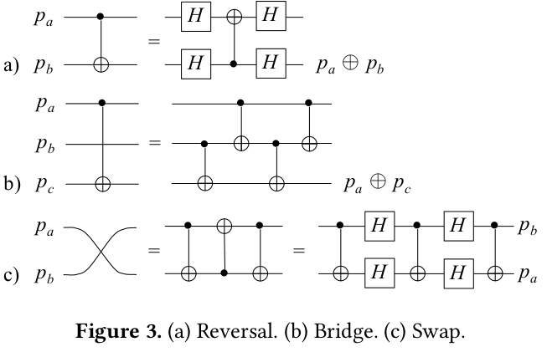
Taking use of the transformation above, we can find a correct mapping between pseudo qubits and physical qubits which enables the implementation of the quantum circuit on a real hardware. Actually, the combination of swap and reversal transformation is enough to implement any quantum circuit and all the papers related to qubit allocation only focus on these two transformations. The algorithm to find a mapping is very simple. The first step is to set an initial mapping randomly, and then check the dependency sequence to see if each CNOT gate can be implemented directly. If current CNOT can be implemented directly, check the next CNOT gate. Otherwise, do some transformations to make the CNOT work. After repeating this process, the dependency sequence can be satisfied.
Take the quantum circuit above as an example. First we need to do an initial mapping. We use the capital Qx to represent a physical qubit in the hardware and the lowercase qx to represent a pseudo qubit in the quantum circuit. Our initial mapping: q0 →Q0 , q1 → Q2 , q2 → Q3 , q3 →Q1 . Then we take a look at the dependency sequence and find that CNOT(q0, q1) and CNOT(q2, q1) can be implemented directly because such directed links Q0 → Q2 and Q3 → Q2 exist in the hardware. However CNOT(q1, q3) cannot be implemented because the edge between Q2 and Q1 is from Q1 to Q2. So we can do a reversal transformation to the edge and CNOT(q1, q3) is feasible. The last operation CNOT(q0, q2) cannot be implemented because there’s no edge between them. To solve this, we can swap q1 and q2, and then implement a CNOT(q0, q1) gate. This is equivalent to the operation CNOT(q0, q2). Till now we complete the qubit allocaiton process of the quantum circuit. Here is the final quantum circuit after transformations.
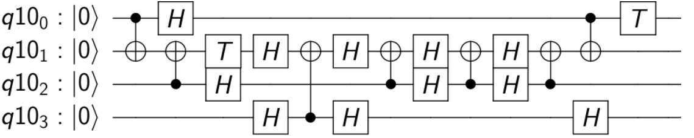
Error-oriented Model:

All the discussion above are based on the assumption that quantum computer has no errors. If it’s true, the problem of qubit allocation has been solved. However, the actual quantum computer suffers from great error which is much worse than classical computers because of the difference in physical foundation. There exists Quantum-Error-Correction-Codes designed for correcting physical errors which is executed above the underlying technology such as trapped ions and semiconductors. However such error-correction layer needs a lot of auxiliary qubits which cannot be afforded by the current hardware. So the most feasible way to reduce the error in quantum computer is to optimize every layer in the software toolflow including the qubit allocation process.

To reduce the error in qubit allocation layer, we need to know the sources of error. Then we can do more optimizations which is directed against the sources. There are mainly 2 kinds of error in quantum computer, retention error and operation error.

Retention error can be called coherence error as well. The cause of this error is decoherence. This is a physical term which describes a quantum phenomenon that the state of a qubit tends to be different with the original one with time passed even without operations on it. There are 2 kinds of retention error. First, the state 1 with high energy may convert to the state 0 with low energy spontaneously because of the physical principle that state with lower energy is more stable. Second, the state 0 may interact with the environment and absorb extra energy from the outside, and then convert to state 1. These two kinds of error all suffer from execution time. We can quantify them with the average execution time before the certain kind of error occurs. Therefore, to reduce this kind of error, we need to abridge the execution time of the quantum program, which means smaller depth of the synthesized quantum circuits. To optimize the depth of quantum circuits, we expect to introduce less additional gates in the process of qubit allocation.

Operation error is more understandable. The physical implementation of quantum gates in ibmqx series is microwave. Doing operations on qubits may induce unexpected deviations to the state of qubits, which means operation error. Single-qubit gate error and two-qubit error comprise the operation error which is dominated by the latter one. To reduce operation error, firstly we need to minimize the quantum gates in the circuit, which means introduce less additional gates in qubit allocation. Secondly, we always expect the operations to be done on the most reliable physical qubits and edges considering not all the physical qubits are the same in the hardware. Different physical qubits and the links between them may have different error-rate when doing single-qubit or double-qubit operations on them because of the underlying technology. The most reliable physical qubits and edges have the lowest error-rate so we expect to implement the required CNOT gates and single-qubit gates on them as much as possible.
Therefore, in order to reduce execution time and operation error, the goal of qubit allocation is to lessen the total gates and do operations on more reliable qubits and links. We can optimize the problem from the two aspects.

Lessen the total gates
With the goal of less gates in the final quantum circuit, our metric is the total count of gates. As discussed above, we need to take use of transformations and introduce additional gates to make our mapping possible. We can see that introduce a reversal transformation will add 5 gates (including the original CNOT gate) to the circuit, so the gate cost of reversal is 5. Similarly, the gate cost of swap is 7. Bridge is special because its gate cost depends on the edge direction which may bring great optimization as discussed below. The basic transformation used in quantum circuits is swap, so we always want to use the least swap transformations to implement the dependency sequence.
There must exists a mapping strategy with its swap path which can have the least gate cost.

However, in order to find the exact solution, we need to traverse all the possible mapping conditions and try different swap transformations to switch among them. This has been proved to be a NP-complete problem. When the number of qubits becomes very large in the future, this solution is not practical. Instead we can use a heuristic solution. We can initiate the mapping randomly and find the shortest swap path to implement the current CNOT gate in the dependency sequence until the whole dependency sequence is satisfied. This is similar to the shortest path problem in a graph and Floyd Algorithm is suitable for solving it. This is the simplest model of qubit allocation. There are many papers trying to give a better solution and optimize the count of gates with new algorithms. All these papers are based on two transformations, swap and reversal. Here, we propose a new algorithm which also takes bridge transformation into consideration. With a series of optimizations, our algorithm shows 11.5% reduction in the gate cost and much faster speed compared with the latest proposed algorithm for qubit allocation.

Bridge Algorithm
Before using bridge transformation, we should discuss about the gate cost of bridge. Bridge transformation is conducted between two second nearest neighbor. For example, we assume the initial mapping is qa → Qa, qb → Qb, qc → Qc. There’s an edge between Qa and Qb, Qb and Qc. The next operation we want to implement is CNOT(qa, qc). As discussed above, the gate cost of bridge depends on the edge direction between Qa and Qb, Qb and Qc. There are 4 possible situations. Under the first situation, both CNOT(qa, qb) and CNOT(qb, qc) can be implemented directly so the gate cost is 4. Under the second situation, CNOT(qa, qb) can be implemented directly but CNOT(qb, qc) needs a reversal transformation. We can draw the circuits with reversal, and some Hadamard gates offset each other because of the equation HH=I. The gate cost is 10. Similarly, we can get the gate cost of the third and forth situation. Their gate costs are both 10.

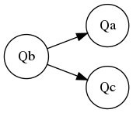
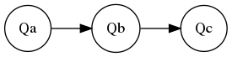

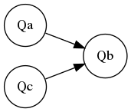

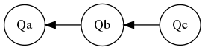

Then we take a look at the effect of swap transformation on the 4 situations. We assume that we always swap the controlling qubit. Under the first situation, we need to swap once and implement a CNOT gate, so the gate cost is 8. Under the second situation, we need to swap once and do another reversal, so the gate cost is 12. The third situation and the forth situation are similar to the first one and the second one, their gate costs are 8 and 12 respectively. So except the third situation, bridge transformation can have less gate cost than swap.

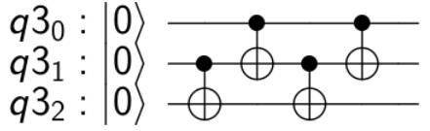

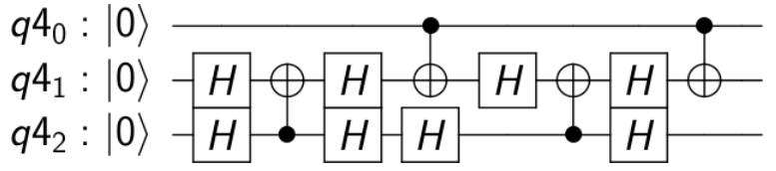

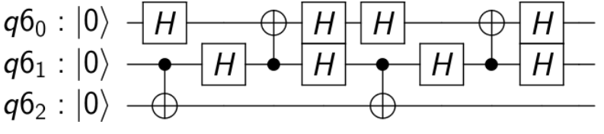

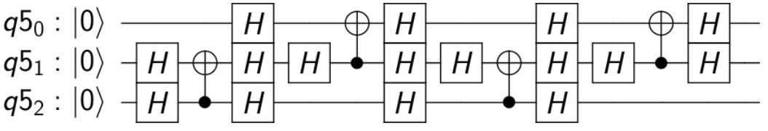

Actually, the advantage of bridge transformation is far more than that. We can list the advantages of bridge and then give some examples to show how it can reduce the total gate cost. First, it’s obvious that bridge has less gate cost than swap under most situations. Second, bridge can avoid latent swap in the next CNOT operation. The controlling qubit and the controlled qubit must be adjacent to each other when only using swap. If we moved the controlling qubit to the neighbor of the controlled qubit, and the next operation also needs to move the original controlling qubit, it has to be swapped back. Through bridge transformation the controlling qubit can interact with the controlled qubit without being adjacent to it. If the original controlling qubit is used again in the next CNOT operation, one swap transformation or 7 additional gates may be saved. Third, the Hadamard gates introduced by bridge transformation are on the periphery which can offset other Hadamard gates introduced by other bridge and reversal transformations or the original ones in the circuit. Hadamard gates introduced by both of bridge and reversal transformation are peripheral ones which can offset other Hadamard gates in the outside circuit because of HH=I. This can bring a huge reduction in the total gate cost because of the spatial locality of quantum program which means the CNOT gates on a certain set of qubits tend to appear continuously in a quantum circuit. And almost all the Hadamard gates in the original quantum circuit appear after CNOT gates in the real benchmark. All the factors contribute to the great reduction based on the offset Hadamard gate. In the following examples, we assume the initial mapping is qx → Qx where x=0,1,2,3,4.
Example2:
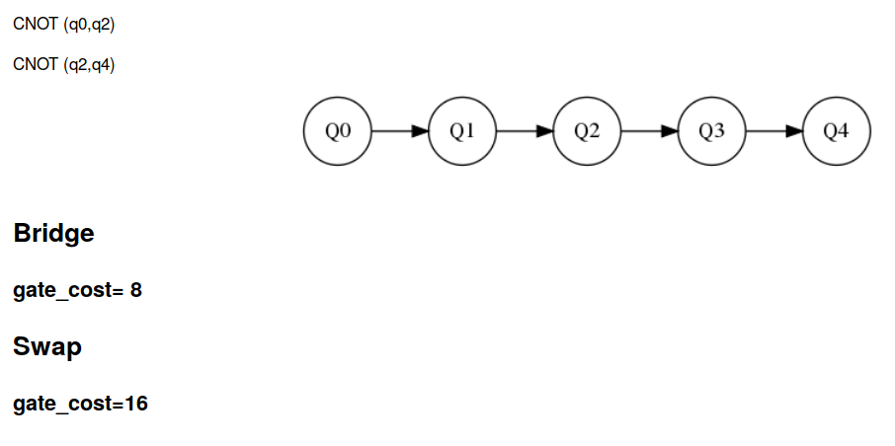
If we use swap only, we need to swap(q0, q1) to implement CNOT(q0, q2), and then swap(q3, q4) to implement CNOT(q2, q4). With bridge, CNOT(q0, q2) and CNOT(q2, q4) can be directly implemented without moving any qubit. The gate cost is 16 and 8 respectively.

Example3:
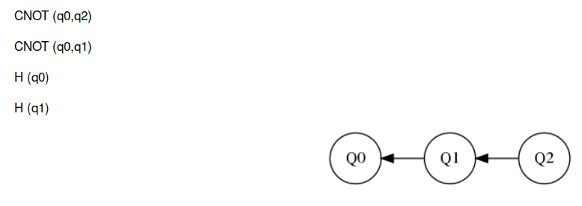
Using swap only, the best solution is to swap(q0, q1) and then do a reversal between q1 and q2 to implement CNOT(q0, q2). The following operations can be implemented directly and the total gate cost is 15.

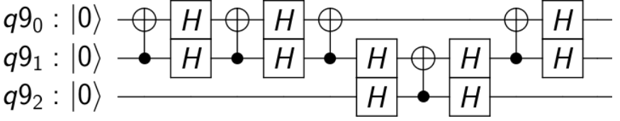
Through bridge transformation, we can implement a bridge circuit between q0 and q2, and then a reversal between q0 and q1. Here is the quantum circuit after transformations. We can find that many Hadamard gates introduced by bridge and reversal offset each other. Also the Hadamard gates in the original circuit offset the ones in the transformation circuit. The gate cost is 9 which is better than using swap only. Such kind of offset is a big benefit of bridge transformation which leads to a huge reduction in total gate cost.

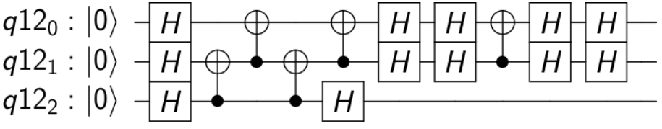
Example4:
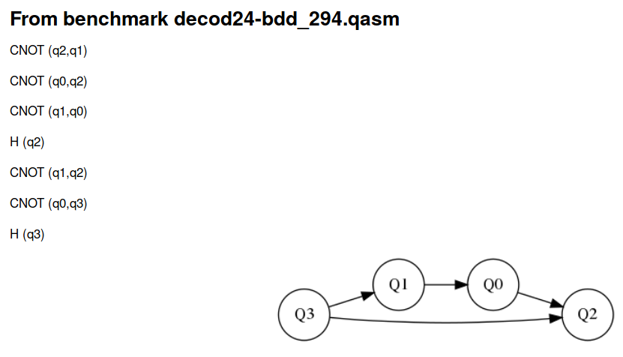
This is a segment of benchmark decod24-bdd_294.qasm and the initial mapping can be found in the hardware ibmqx5. The best solution with swap only is: swap(q1, q0), reversal(q0, q2), swap(q1,q0), CNOT(q0, q2), CNOT(q1, q0), H(q2),s wap(q1, q0), CNOT(q0, q2), reversal(q1, q3), H(q3). The total gate cost is 34.
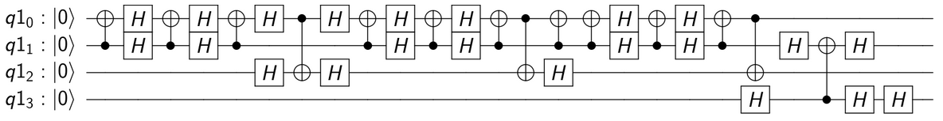

Through bridge, all the CNOT gate can be directly implemented without swapping any qubit. Here is the circuit after transformations. We can see that bridge can avoid latent swap in the next operation to reduce additional gates. The total gate cost is 26.
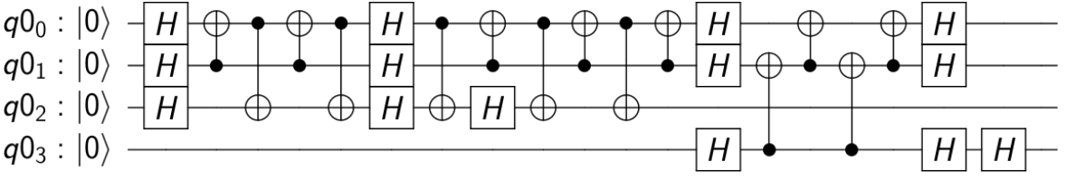
Algorithm

To take better use of bridge transformation, we need more optimizations in the real qubit allocation process, including finding an efficient initial mapping and cutting layers to find a local best order for implementing CNOT gates.

Initial mapping

The original strategies for initial mapping are randomly distribution or mapping the pseudo qubits with most appearing frequency in the dependency sequence to the physical qubits with maximal out-degree in the hardware graph. The latter one seems reasonable because it has considered the pattern of dependency sequence. However, when the pseudo qubits used in the quantum circuits is much less than the number of physical qubits in the hardware, they may be scattered sparsely in the hardware. It may cost additional swaps to move them together for implementing CNOT gates. What’s more, such initial mapping cannot show the power of bridge transformation which enables a qubit to interact with other qubits in a larger scope. So we propose a new initial mapping approach.

The physical qubits in the hardware have difference in not only out-degree, but also location priority which shows the difficulty for the qubit to interact with any other qubit in the hardware graph. It’s easy to find that the average gate cost for a physical qubit to interact with any other qubit is the lowest in the central area of the hardware graph. It’s a good choice to map the most frequent pseudo qubits appearing in the dependency sequence to the central area of the hardware graph. Therefore, our initial mapping is to map the pseudo qubits to the physical qubits with corresponding location priority according to their frequency in the dependency sequence. Take ibmqx5 as an example. The location priority decreases successively from the central area to the two sides. We can establish a ranking array [4 13 5 12 14 6 11 3 10 15 7 2 0 9 8 1] which represents the order of physical qubits based on location priority and map the pseudo qubits to them in turn according to their frequencies. The first benefit of such an initial mapping is that when the number of pseudo qubits in the circuit is much smaller than the physical qubits in the hardware, they naturally get together after initial mapping which need no additional swap. The second benefit is that the most frequent pseudo qubits get the best location priority so they can interact with a large scope of qubits without swap, which means more operation can be done through bridge. This is conducive to reduce the total gate cost.

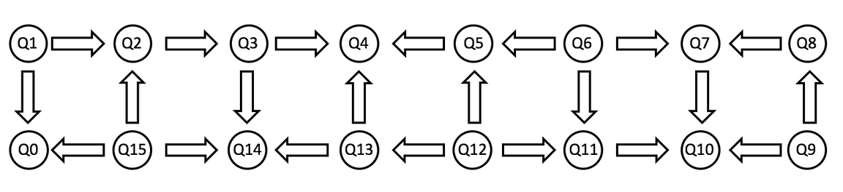

Allocation Process

Here’s the heuristic solution with bridge transformation. Before allocation, we need to analyze the hardware graph to get a route matrix where routeMatrix[i][j] records the next qubit to swap to if we want to move qubit i to j. We can get such a route matrix through Floyd algorithm which is used for shortest path problem in a graph. After initial mapping, for each item in the dependency sequence, we check if it can be implemented directly or through bridge and reversal. If yes, we just implement it. If no, it means additional swaps are needed and we can swap the controlling qubit to the second nearest neighbor of the controlled qubit where bridge transformation can be implemented. The swap path can be established according to the route matrix. All the CNOT gates can be implemented in this way and the dependency sequence can be satisfied.

Such a heuristic solution is the basic model for qubit allocation which needs more optimization. Actually, the implementation order of unrelated CNOT gates is very important. Unrelated CNOT gates means that the operands of them have no repetition such as CNOT(q0, q2) and CNOT(q1, q3). If we have a set of unrelated CNOT gates, which one to implement first has no influence to the final logic, but it has large effects on the total gate cost. The reason is that when you swap a qubit to its destination, you change the position of the qubits in your swap path as well. This may influence the swap number needed by the following operations. The implementation order is more important when considering bridge because the Hadamard gates can offset each other more with a better order. Therefore, we can cut the dependency sequence into layers and each layers contains a set of unrelated CNOT gates. For each layer, we try every possible implementation order of its CNOT gates and return the best one with least gate gost. After dealing with all the layers, we can get the total gate cost and finish the process of qubit allocation. To decide the size of each layer, we can set a parameter called Readahead to decide how many operations to check when the first conflict happens. A conflict happens when the operands of next operation have been used by a CNOT gate in the current layer. When the first conflict happens, we continue to check the following Readahead operations in the dependency sequence and see if they can be assimilated into current layer. After getting the best implementation of this layer, we return to where the first conflict happens and start a new layer. Actually, the Readahead parameter is a problem of gate-depth tradeoff. If the parameter is large, more gates will be implemented in a specific order, which decreases the total gate cost and also reduces the parallelism of CNOT gates, or to say, increase the depth. Otherwise, more CNOT gates can be implemented in a parallel way but the total gate cost won’t be so small.

Pseudo codes:

"""
Function Allocation

input: // keep the operation sequence, if CNOT gate, the first index is the controlling qubit, the second index is the controlled qubit;
// if single-qubit gate, the first index < 0, the second index is the operand qubit.
int[] mapArray // initial mapping, mapArray[i] is the pseudo qubit number which is mapped into physical qubit i
int[][] routeMatrix // keep the path for two physical qubits generated by Floyd algorithm

output: total gate cost
"""

Function Allocation(int[][] seq, int[] mapArray, int[][] routeMatrix)
{
totalcost=0;
cnt=0;
record=infinity; // keep the position where conflict happens
mincost=infinity;
bool start_cnt=false;
int[][] worklist; // keep the CNOT gates in the current layer
bool[] seqitem(seq.size(),true); // if seqitem[i]==true, it hasn't been implemented by the layers before. Otherwise it has been implemented.

for i in range(seq.size())
{
if(start_cnt)
cnt++;

if(seq[i][0]<0 && seqitem[i]) // unimplemented single-qubit gate
{
if(seq[i][1] in worklist) // conflict happens
{
start_cnt=true;
record=record<i?record:i;
}

else
{
Implement_Directly(); // No conflict, then implement it directly
totalcost++;
seqitem[i]=false;
}
}

else if(seq[i][0]>=0 && seqitem[i]) // unimplemented CNOT gate
{
if(seq[i][0] in worklist || seq[i][1] in worklist) // conflict happens
{
start_cnt=true;
record=record<i?:record:i;
}

else
{
worklist.push_back(seq[i]); // No conflict, assimilate it into current layer
seqitem[i]=false;
}
}

if(cnt>=Readahead || i==seq.size()-1) // check the following Readahead gates when conflict happens
{
n=worklist.size();
for k in range(n!) // list the full permutation of worklist, try each possible order and find the one with minimal gate cost
{
mapArray_copy=mapArray;
Permutaion(worklist);
cost=subAllocation(worklist,mapArray_copy,routeMatrix);

if(cost<mincost)
{
mincost=cost;
mapArray=mapArray_copy;
}
}

totalcost=totalcost+mincost;

mincost=infinity;
cnt=0;
start_cnt=false;
worklist.clear();
i=record-1;
record=infinity;
}
}

return totalcost;
}

"""
Function SubAllocation

input: int[][] worklist // keep the CNOT gates in the current layer
int[] mapArray // the final mapping in the last layer and also the initial mapping for this layer
int[][] routeMatrix // keep the path for two physical qubits generated by Floyd algorithm

output: gate cost
"""

Function SubAllocation(int[][] worklist, int[] mapArray, int[][] routeMatrix)
{
cost=0;
for i in range(worklist.size())
{
for j in range(qubitNum) // find the corresponding physical qubit of the controlling qubit and the controlled qubit
{
if(mapArray[j] == worklist[i][0])
beg=j;
if(mapArray[j] == worklist[i][1])
dest=j;
}

if(beg → dest)
{
Implement_Directly();
cost++;
}

else if(dest → beg)
{
Reversal();
cost=cost+5;
}

else
{
next=routeMatrix[beg][dest];

while(routeMatrix[next][dest] != dest) // swap the controlling qubit to the second nearest neighbor of the controlled qubit
{
Swap(mapArray[beg],mapArray[next]);
cost=cost++;
beg=next;
next=routeMatrix[beg][dest];
}
// 4 situations
if(beg → next → dest)
{
Bridge_situation1();
cost=cost+4;
}

else if(beg → next ← dest)
{
Bridge_situation2();
cost=cost+10;
}

else if(beg ← next → dest)
{
Bridg_situation3();
cost=cost+10;
}

else
{
Bridge_situation4();
cost=cost+10;
}
}
}

Detect_Hadamard_offset(cost); // offset the continuous Hadamard gates

return cost;
}

Evaluation

We run our algorithm on the benchmarks in the paper XXX. Among the 150 benchmarks, our algorithm has better effects on 132 of them. The average reduction is 11.5% for all the benchmarks and 15.1% for the 132 better ones.
(See the result.odd file. More details need to be added.)

More reliable qubits

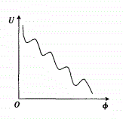
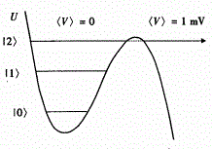
To figure out the sources for operation error, we need to have an overview of the physical foundation of ibmqx series which is based on superconducting quantum interference device. The underlying structure of superconducting quantum circuits is Josephson junction. It is constructed by two superconductors with a very thin insulator between them which forms a barrier. The cooper pairs made of two electrons can get through the barrier and generate superconducting electricity because of tunneling effect. The system’s energy changes with the phase difference of wave functions between the two sides of Josephson junction. When the temperature is very low, the system’s energy is divided into discrete energy levels which can represent a quantum state each. From the wave function aspect, it can be seen as an electromagnetic wave oscillating back and forth in a potential well.

To manipulate the qubits, we exert microwaves on them so that they can jump between different energy level. But the microwave operations are not accurate enough so the final states of the qubits may have difference with our ideal result. This is the source of operation error and CNOT gates have more serious deviation than single-qubit ones. For example, the most common kinds of single-qubit gates error are phase drift and crosstalk. Phase drift is that when you manipulate a qubit and expect its final state to be \alpha 0 + \beta 1, but actually it turns to be \alpha 0 + \beta exp{i\phi} 1 which has a phase error. Crosstalk means that you do a single-qubit operation on this qubit but the states of qubits connected with it are influenced as well. This is because the electromagnetic wave may be dropped a little from this qubit to its neighbors and incur error. The accumulation of such kinds of deviation will lead to the failure of the program.

There’s a fact that not all qubits are the same which means that single-qubit gates on different physical qubits or CNOT gates on different links have various error rate. So we always want to do the operations on more reliable physical qubits or links. For CNOT gates which dominate the operation error, the paper has run benchmarks on real ibm hardware for 52 days and measured the probability of successful CNOT operation on each link. We can see different links have obvious difference in success probability. Considering this fact, we can give each edge a weight representing the success probability and the total success probability of a path is the product of the links’ success probability in the path. We can do a trade off between additional gates and the total success probability of each path to select the best path through modifying our Floyd algorithm which generates the route matrix for finding the swap path. This thought is similar to the method proposed by the paper. To do better optimization, we can assume that all the links have same success probability and focus on the single-qubit gates error including phase drift and crosstalk.

Crosstalk is the interference between connected qubits. It’s in proportion to the coupling strength which represents the degree of correlation of connected qubits. If a physical qubit has connection with a lot of qubits and the coupling strength between them is high, crosstalk error tends to occur on this physical qubit, that is, when you do operations on this qubit, its neighboring qubits tend to be influenced as well. Every link has a coupling strength, we can sum up the coupling strength of one physical qubit with its neighbors to represent the crosstalk error of this qubit. Taking drift error into consideration, we can sum the drift error and crosstalk error to denote the single-qubit gate error of a qubit.

We can improve our algorithm when considering single-qubit gate error. For a physical qubit, the single-qubit gates between two CNOT operations on it can be implemented anytime between the two CNOT operations without changing the logic. Therefore, we can keep all the single-qubit gates on a physical qubit without implementation until the next CNOT operation on it. If the qubit needs to be swapped to its destination, we can find the physical qubit with least single-qubit gate error in its swap path and implement all the saved single-qubit gates on that qubit. Otherwise we can implement all the gates in the original position. It’s not worthy to introduce additional swaps for reducing the single-qubit gate error, our improvement introduces no additional swap and has no other side effect.

IBM has offered the crosstalk strength of each pairs of connected physical qubits which is a reference for crosstalk error. We can convert the error to the equivalent gate cost as a metric for our algorithm. We assume that the equivalent gate cost of the crosstalk error for each link is in proportion to the crosstalk strength, so the crosstalk error for a physcial qubit is the sum of the gate cost of the links from it. We set the minimal crosstalk error to be 1 gate and the maximal gate cost to be 2 gates. We also assume the drift error is 0 which will not influence the correctness of our algorithm. The improved algorithm reduces 2.1% in total gate cost of the original one without optimization for single-qubit gate error. If the equivalent gate cost for crosstalk is actually larger than we think or the difference in drift error is also considered, the reduction will be more obvious.

Architecture Design

All our experiments are conducted on the hardware ibmqx5 to make a comparison with the past work. However, the hardware graph of ibmqx5 is not the most suitable architecture with 16 physical qubits to show the power of bridge transformation. Here we can design a new architecture with 16 qubits to take better use of bridge.

First we need to come up with the base model for hardware architecture with 16 qubits. It’s obvious that a 4*4 array is easier for qubits to get each other through swap, which reduces the necessary swap number. Whether use bridge or not, such 4*4 array is a good choice. Then we need to decide the direction of each edge, which is important especially for bridge transformation because under different situations the gate costs are different. Among the 4 situations discussed above, the best choice is the first one with 4 additional gates. But this is not always feasible. Among the other 3 situation, the forth one is the most ideal situations because its 6 additional Hadamard gates are all in the periphery which can offset the other Hadamards in the circuit. While the second and third situation only have 3 peripheral Hadamard gates and the total gate cost is the same with the forth one. Therefore, we always expect the first situation and the forth situation in our architecture.

For example, among the following 3 subgraph we always want the second one. The reasons are as follows. The first graph seems ideal but it is prohibited in the true hardware. As discussion above, only the qubit with high physical frequency can control the qubit with low physical frequency so that the hardware graph must be a directed acyclic graph. That’s why the first subgraph is prohibited. The second one is best among the left two subgraphs because between two nonadjacent physical qubits only situation 1 and 4 can be found. While there exists situation 2 and 3 in the third subgraph. Therefore, the second subgraph can have better effect for bridge.
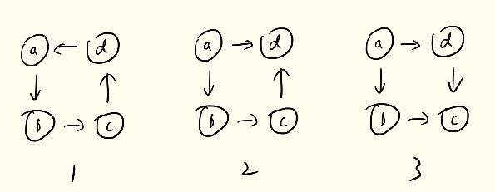

Here are our rules for designing the hardware architecture with given physical qubit number. First, the length and width of the architecture lattice formed by physical qubits should be close. For example, given 16 qubits, 4*4 architecture is better than 2*8 architecture because the former one has the less average swap number for qubits to get each other. Second, when implementing bridge transformation we desire more cases of situation 1. Considering the restrict of acyclic graph, we expect more cases of situation 4 based on the most cases of situation 1. This encourages us to adopt subgraph2 in our architecture design.

Based on the rules we design our new architecture named ibmqxm. We can see that this architecture is comprised by the second subgraph. Any qubit can implement a CNOT gate with any of its second nearest neighbors through bridge situation 1 or 4. We run all the benchmarks on ibmqxm again and compare the result with the one generated by the same bridge algorithm on ibmqx5. Among the 150 benchmarks, the algorithm on ibmqxm has less total gate cost in 142 benchmarks and the average gates reduction is 14.5%.
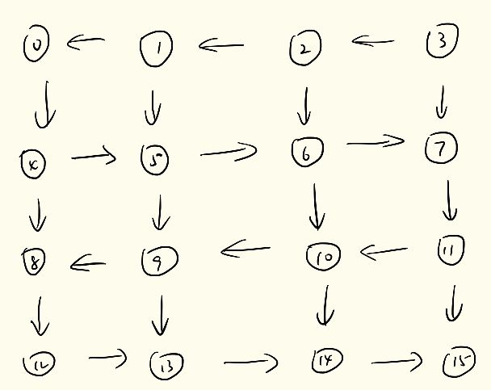
We conduct another experiment to manifest that ibmqxm is one of the best architectures to take use of bridge transformation. The initial hardware graph is ibmqxm. We randomly choose several edges and change the directions of them, then run all the benchmarks on the hardware again to see if the result is better than ibmqxm. We try 10000 variants of ibmqxm and compare their results with the one of ibmqxm on the 150 benchmarks. We find that no variant can have better results on more benchmarks than ibmqxm.

Pseudo Codes:
Function CompareArchitecture( Hardware ibmqxm )
{
hardware = ibmqxm;
result_ibmqxm=RunAllBenchmards(hardware);

for i in range (10000)
{
if( i%100 )
hardware = ibmqxm;

RandomChange( hardware );

result=RunAllBenchmards( hardware );

Compare( result, result_ibmqxm );
}
}

Our result can guide the future hardware design as well. Given the number of physical qubits, we can generate the architecture through piling the periodic unit subgraph2. For example, with 30 physical qubits, we first factorize 30 to two close numbers 5*6, then build the hardware graph with the periodic unit subgraph2.

